Command-Line Monitoring of Antminer Hardware Using BOSminer API
In recent history, I was able to flash Braiins OS+ firmware to my Bitmain Antminer S17 lab unit. To my knowledge, I am the only person who has managed to brick a control board while trying to flash Braiins OS to a miner and, after getting a replacement, I finally have the OS up and running. Comparing it to NiceHash OS, I have a strong preference for BOS, as you have more intuitive controls, ability to limit miner power consumption, and an autotuning feature that delivers fantastic performance. In my experience, paying the dev fee is worth it for the “plus” version, and if you use their mining pool then they’ll waive the pool fee.
But the main reason I like Braiins OS is the BOSminer API, that allows you to poll the device from the command line. The exchange is over simple jquery, so you can use various ways to interact with the miner. My personal choice is plain, dumb, bash. Enough with the preamble, let jump in.
The basic query structure for polling a miner running Braiins OS follows:
$ echo '{"command":"<command>"}' | nc <ip_address> 4028 | jq .
Ex:
# get fan speed info:
$ echo '{"command":"fans"}' | nc 192.168.0.101 4028 | jq .
Note that I run the output through jq just to make it easier on the eyes. Later, we will use the jq command to grab parameters that we want from the API results.
List of favorite commands and a description:
devdetails - details on each hashboard, including frequency and voltage
devs - similar to summary below, but details are broken out by each hashboard
fans - reports back fan speeds and duty
tempctrl - shows the current temperature control settings
temps - reports the actual temperatures of hashboards and chips
tunerstatus - where in the tuning cycle the machine is, and if it’s stable
summary - reports various hashrates for the entire unit, difficulty, shares accepted, total hashes, time elapsed, and more
So, we want to create a simple polling program to grab various performance factors, namely hashrate, and total hashes. I will summarize the code below, but a working set of scripts can be downloaded from my github, located here:
davewhiiite/bosslogger
Shell scripts for logging data from bitcoin miners using Braiins OS firmware README.md "bosslogger" is a shell script…github.com
Here’s the program’s basic control scheme:
bosslogger.sh (infinite while loop, calls polling script every 60, 300, 900 seconds) → log_reading.sh (script to poll the miner, prints to standard out) → output to .csv file.
That’s it. You use the script(s) to log to comma-delimited text file, then can do what you like, such as load the data into a Postgres database, manipulate with Python or Pandas, whatever.
Creating a script for polling the miner: log_reading.sh
#!/bin/bash
# filename: log_reading.sh
# take address info as inputs:
ip_address=$1 # ex: "192.168.1.111"
port=$2 # ex: "4028"
# date string used as a timestamp in the output
date_str=`date +"%Y-%m-%d %H:%M:%S"`
# read the entire output of the "summary" command from the BOSminer API.
miner_info=`echo '{"command":"summary"}' | nc $ip_address $port | jq .SUMMARY | tr -d [:space:]`
# Pick the various API properties from the "summary" command that you want to use, comment out the rest:
Accepted=`echo $miner_info | jq .[0].Accepted`
DifficultyAccepted=`echo $miner_info | jq .[0].DifficultyAccepted`
Elapsed=`echo $miner_info | jq .[0].Elapsed`
MHS15m=`echo $miner_info | jq .[0].MHS15m`
MHS1m=`echo $miner_info | jq .[0].MHS1m`
MHS5m=`echo $miner_info | jq .[0].MHS5m`
MHSav=`echo $miner_info | jq .[0].MHSav`
TotalMH=`echo $miner_info | jq .[0].TotalMH`
# convert MH/s to more legible, usable TH/s:
# scale = 1 means 1 decimal point. Add more if you want.
THS15m=`echo "scale=1; $MHS15m / 1000000.0" | bc -l`
THS1m=`echo "scale=1; $MHS1m / 1000000.0" | bc -l`
THS5m=`echo "scale=1; $MHS5m / 1000000.0" | bc -l`
THSav=`echo "scale=1; $MHSav / 1000000.0" | bc -l`
TotalTH=`echo "scale=1; $TotalMH / 1000000.0" | bc -l`
# prints the output. format is dumb, comma-delimited strings. Note that file header is provided in the controlling program
echo "${date_str},${Accepted},${DifficultyAccepted},${Elapsed},${THS15m},${THS1m},${THS5m},${THSav},${TotalTH}"
Basic Control Loop Program: bosslogger.sh
#!/bin/bash
#input miner info
ip_address="192.168.1.111" # change to your miner's address!
port="4028" # default port number is 4028
sampling_interval_sec=60 #sampling time in seconds. Recommended intervals are 60s, 300s, 900s (1m, 5m, 15m)
# sets an output file. change as desired
date_str=`date +"%Y-%m-%d_%H_%M_%S"`
outfile="outfile_${date_str}.csv"
# prints the header to the output file.
echo "Datetime,Accepted,DifficultyAccepted,Elapsed,THS15m,THS1m,THS5m,THSav,TotalTH" >> $outfile
# simple, infinite loop to log each reading to the output.
# note: log_reading.sh does the interacting with the BOSminer API
while :
do
./log_reading.sh $ip_address $port >> $outfile
sleep $sampling_interval_sec
done
Running the Program
We call the main bosslogger.sh program from the command line, then put it in the background:
$ nohup ./bosslogger.sh
# press ctrl + Z, type bg to put script in background
To monitor the output of your script, just follow the comma-delimited text file that is created:
$ tail -f outfile_2020-10-03_12_46_53.csv
# ctrl + C to exit
Example output from the .csv file:
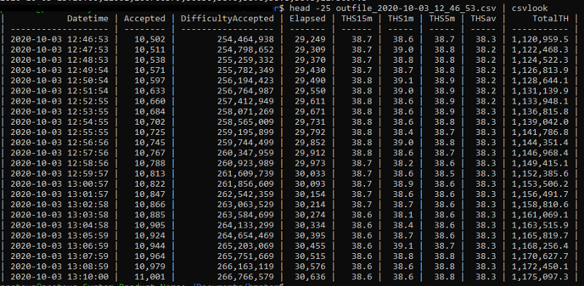Image 1: Sample output data from the bosslogger utility script
That’s the basic functionality. I encourage you to use the BOSminer API to create your own scripts, as they suit your needs. If you found this helpful, please subscribe to the Bitcoin by Command Line blog, and you can find me saying silly things on Twitter: https://twitter.com/DavesWarez
THANK YOU

